**MA4605 Chemometrics Lab C**

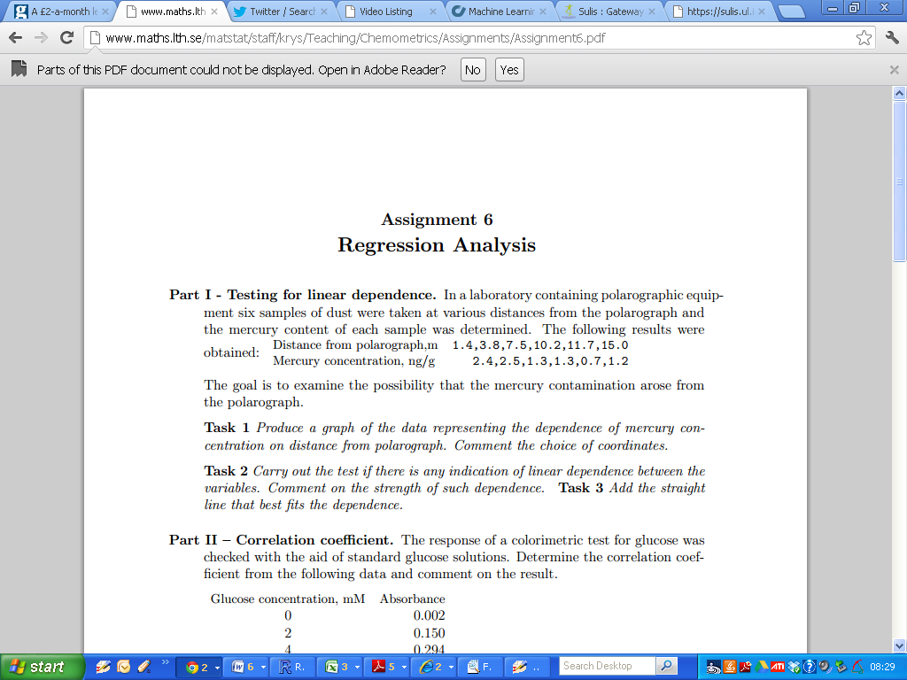

|  |
| --- |
| Dist = c(1.4,3.8,7.5,10.2,11.7,15.0)  Merc = c(2.4,2.5,1.3,1.3,0.7,1.2)  # compute the correlation coefficient  cor(Dist, Merc)  cor.test(Dist,Merc)  # create a scatterplot  plot(Dist, Merc)  # create a linear model  myModel = lm(Merc~Dist)  summary(myModel)  coef(myModel)  # enhanced scatterplot  plot(Dist, Merc, pch=16, col=”red”, cex=1.5)  title(“Scatterplot”)  abline(coef(myModel))  #This adds a line to the scatterplot |

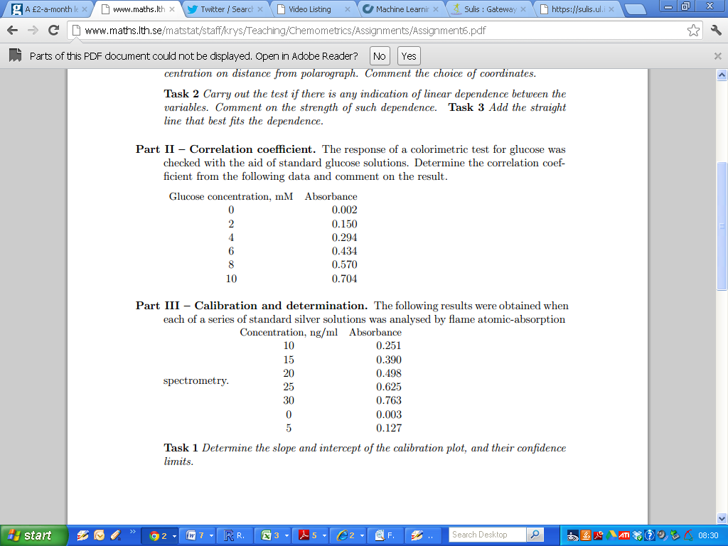

(Additional for 2012: What is the 95% confidence interval for the correlation coefficient)

|  |
| --- |
| # Little Trick  # What does this line of code do?  1:5  #and this one?  (1:5)*2  Gluc = c(0,2,4,5,8,10)  Abs1 = c(0.002,0.150,0.294,0.434,0.570,0.704) |

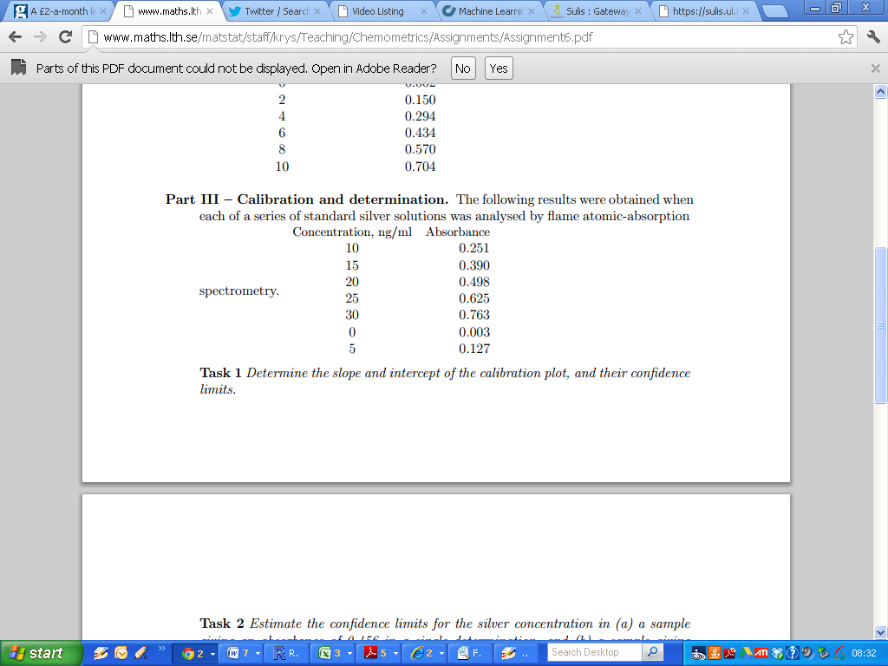

|  |
| --- |
| Conc = c(10,15,20,25,30,0,5)  Abs2 = c(0.251,0.390,0.498,0.625,0.763,0.003,0.127)  # hint: fit a regression model  # Call it something like “RegModel” or “myNewModel2”  # use the commands summary(), coef() and confint() |

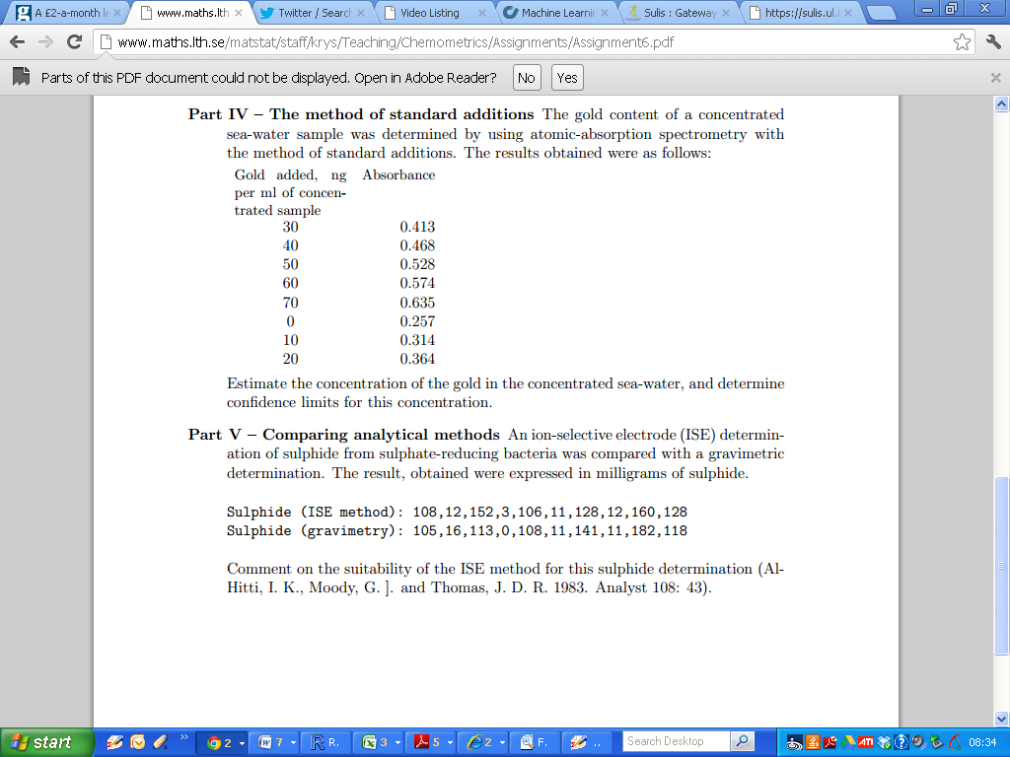

Determine the estimates for the slope and intercept. Additionally comment on the associated p-values from the summary output.

|  |
| --- |
| Gold = c(30,40,50,60,70,0,10,20)  Absrb= c(0.413,0.468,0.528,0.574,0.635,0.257,0.314,0.364)  lm(Absrb ~ Gold)  summary(lm(Absrb ~ Gold))  # look at summary output for asterisk signs |

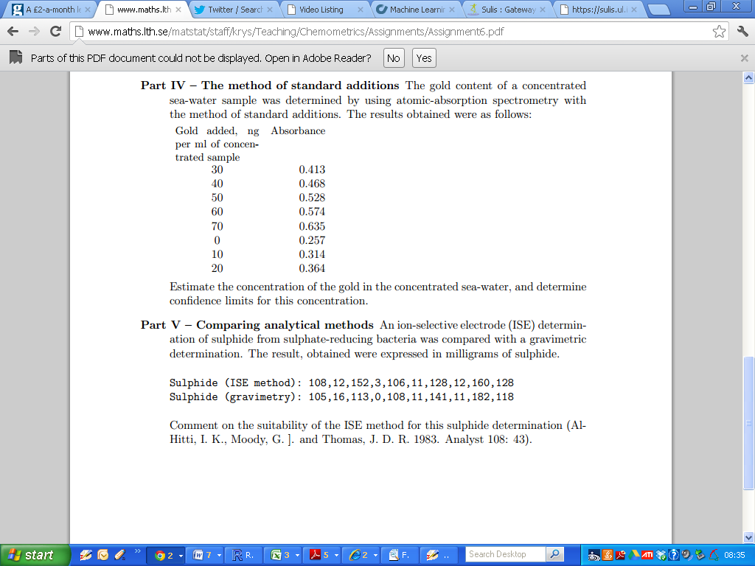

Compute the simple linear regression equation for the case where

1. The ISE method is the independent variable,
2. The ISE method is the dependent variable.

Write down the regression equations for both models.

Which approach (if any) is more suitable?